* **A* Search and Recursive Best-First Search:**

**Code:-**

import heapq

def astar(graph, start, goal):

open_set = []

heapq.heappush(open_set, (0, start))

came_from = {}

while open_set:

_, current_node = heapq.heappop(open_set)

if current_node == goal:

path = reconstruct_path(came_from, start, goal)

print("Path found:", ' -> '.join(path))

return

for neighbor in graph[current_node]:

if neighbor not in came_from:

heapq.heappush(open_set, (0, neighbor))

came_from[neighbor] = current_node

print("No path found")

def reconstruct_path(came_from, start, goal):

current = goal

path = [current]

while current != start:

current = came_from[current]

path.append(current)

return path[::-1]

city_graph = {

'Delhi': {'Mumbai', 'Jaipur', 'Lucknow'},

'Mumbai': {'Delhi', 'Chennai', 'Bangalore'},

'Chennai': {'Mumbai', 'Bangalore'},

'Bangalore': {'Mumbai', 'Chennai', 'Hyderabad'},

'Hyderabad': {'Bangalore', 'Chennai'},

'Jaipur': {'Delhi', 'Lucknow'},

'Lucknow': {'Delhi', 'Jaipur'}

}

start_city = input("Enter the start city in India: ")

goal_city = input("Enter the goal city in India: ")

print(f"Finding path from {start_city} to {goal_city} using A* algorithm:")

astar(city_graph, start_city, goal_city)

**Output:-**

**Path found:-**

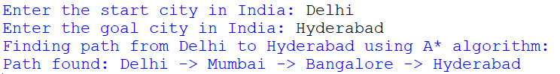

**Path not Found;-**

